Usage Instructions – V1.3.1

## **✅ Step 1: Subscribe to the Product**

1. On the Marketplace Listing page, find the product with the title “**EDI to FHIR Converter**”.
2. Carefully review the “Purchase Options”.
3. The default annual agreement is editable, or a new annual agreement can be created.

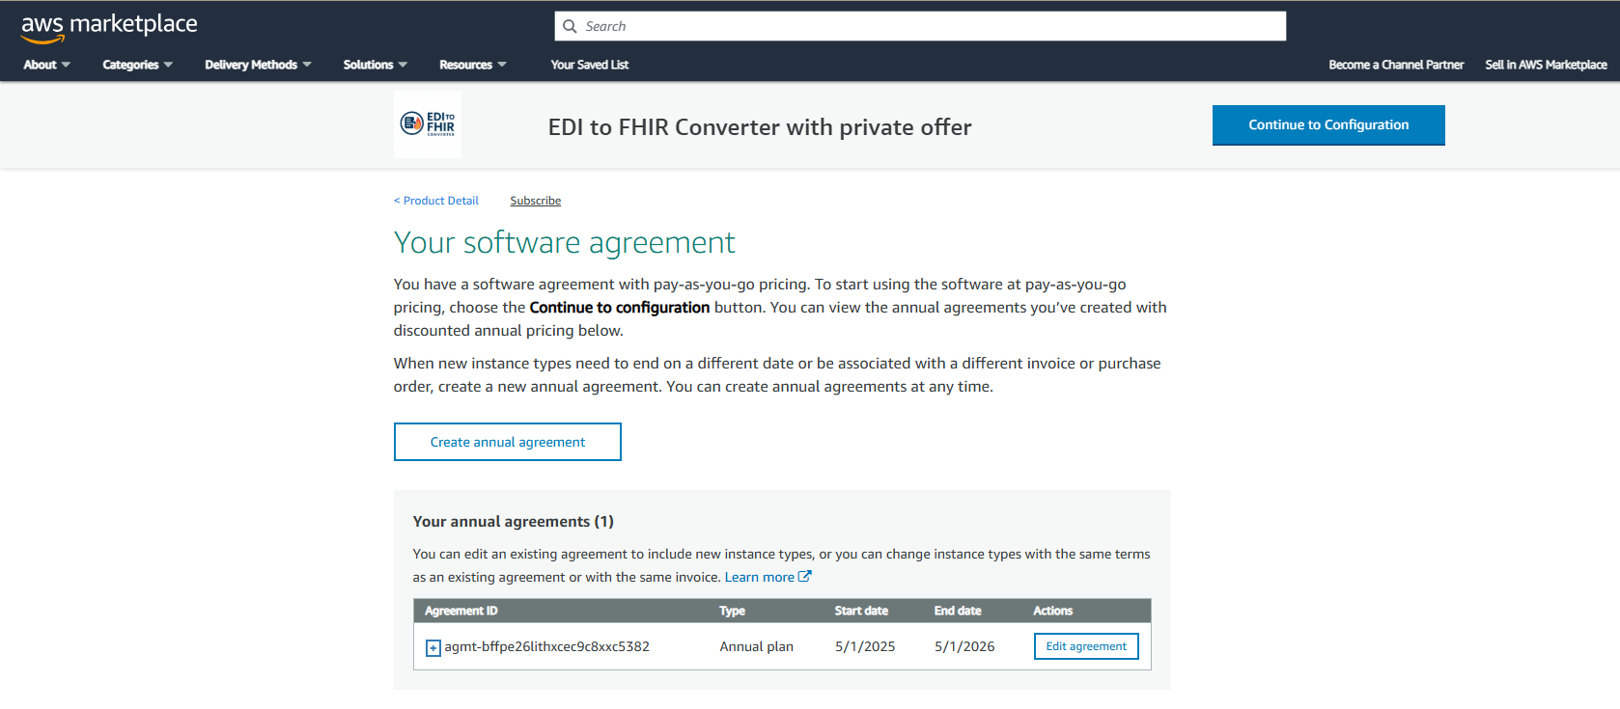

The editable option allows the customer to edit the number of units that are to be to be purchased. By default, the number of units is set to 1. 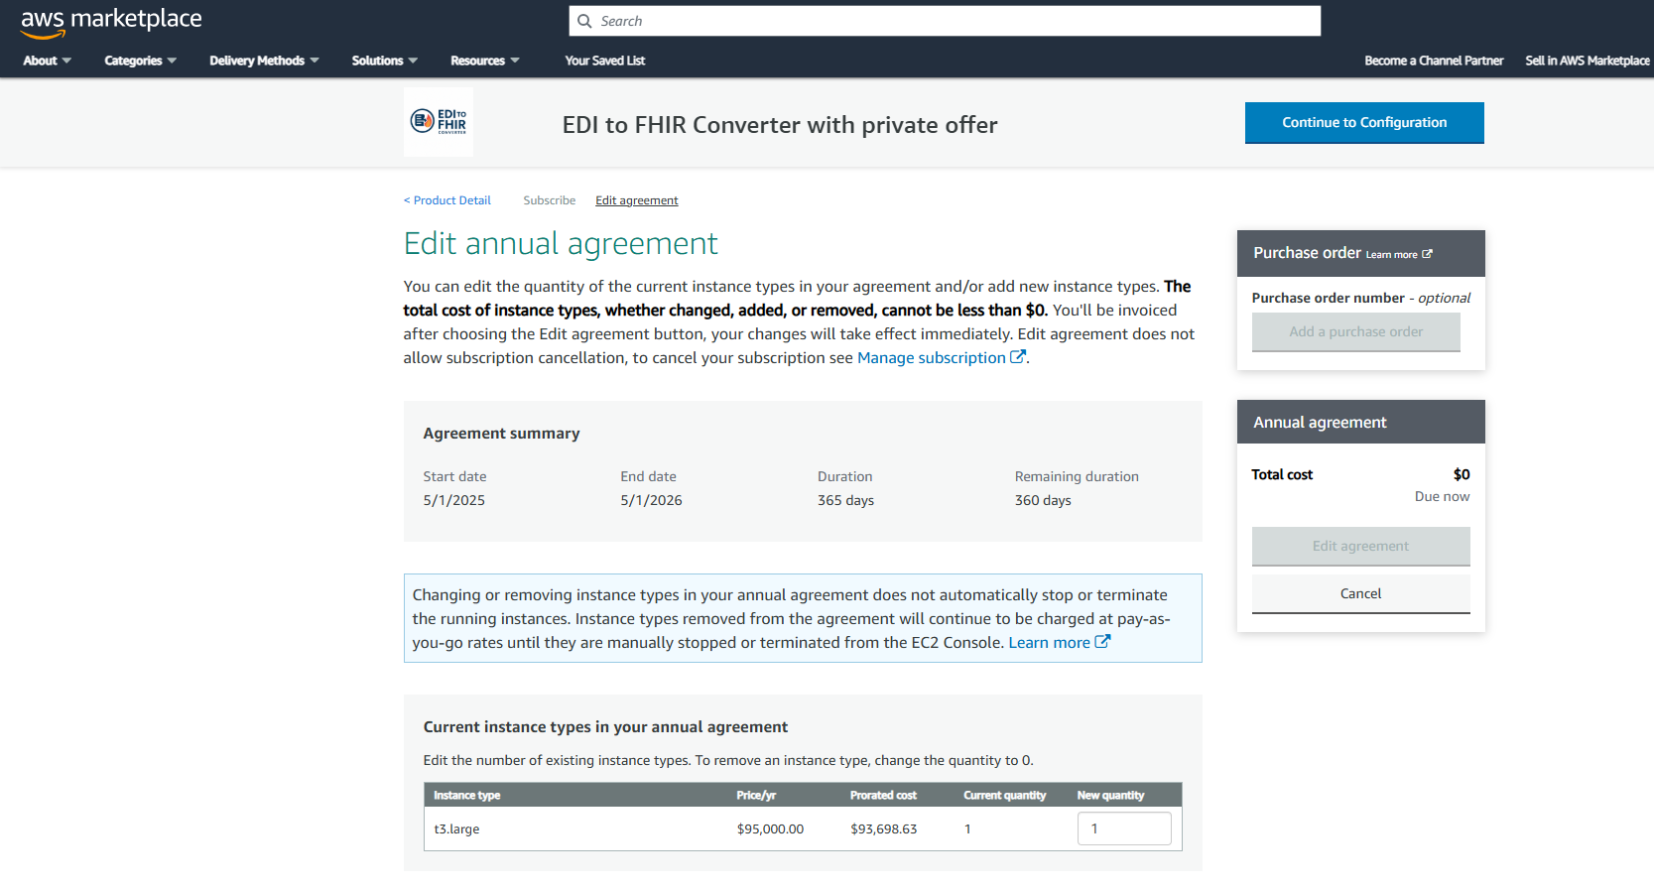 Currently no new instance types can be added. The only available option is t3.large.

**✅ Step 2: Configure and Launch the EC2 Instance**

1. Click 'Continue to Configuration' after subscription. Under “Fulfillment Option”, select “Amazon Machine Image”. 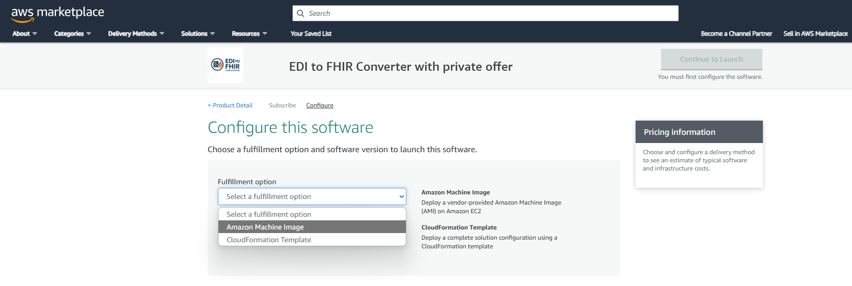
2. Select the appropriate:
   1. Software version
   2. Region (this should match the desired AWS Region for the deployment)

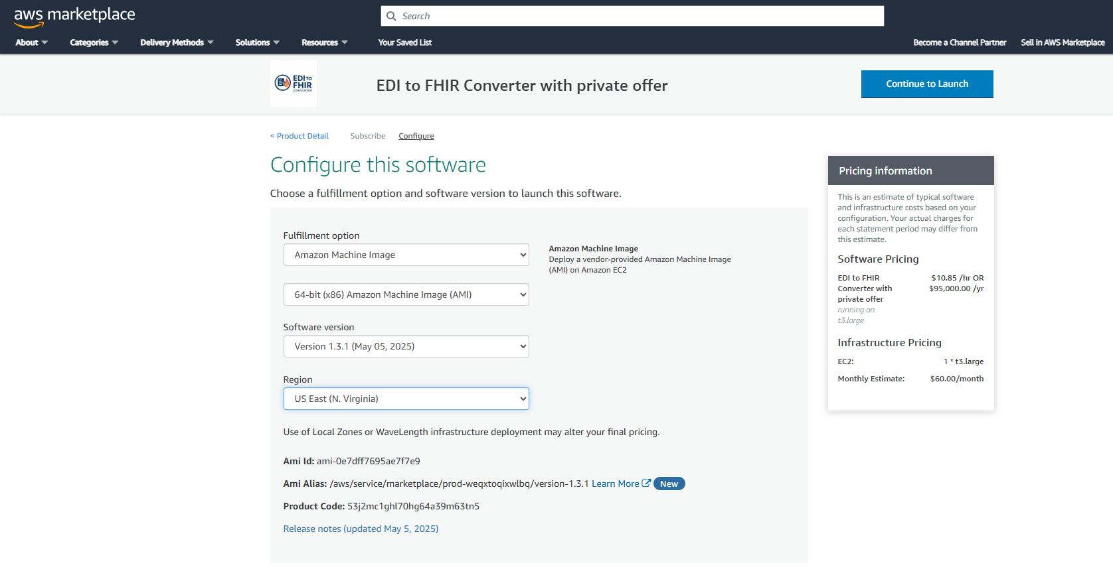

1. Click 'Continue to Launch' to launch the EC2 instance.

**Your EC2 instance is now set up in your AWS account using the subscribed AMI.**

**✅ Step 3: Accessing the EC2 Instance**

1. Connect via SSH to the EC2 instance upon navigating to the folder of the .pem file which is created on the user’s end.

***ssh -i /path/to/your-key.pem ec2-user@<public-ip-address>***

Replace <public-ip-address> with the Public IPv4 address from the EC2 Dashboard.

**✅ Step 4: Navigate to Deployment Directory**

1. Switch to the root user

***sudo su***

1. Navigate to the home directory

***cd ~***

1. Confirm you are in the root directory

***pwd***

It should be at: “/root”

1. Configure the env variables

***cd /etc***

***vim environment***

1. Define the variables given below in Edit mode:

**SSM_COGNITO_USER_POOL_ID, SSM_COGNITO_CLIENT_ID**: Required for the application authorization and must be created on your side.

**SSM_HEALTHLAKE_DB_ID, SSM_HEALTHLAKE_KMS**: Healthlake credentials are required for ingesting the FHIR resources into AWS Healthlake. Future Versions will have this as an optional step.

**CUSTOMER_S3_BUCKET**: This bucket is created on your AWS account to dump the files of the converter app.

**CUSTOM_STACK_SUFFIX**: The suffix is affixed to the default name of the converter app. Separate suffixes for TEST, DEV, PROD are endorsed for the same application.

**AMPLIFY_S3_BUCKET**: Please specify the bucket name in your AWS account that will be used by the converter app to deploy Amplify application code.

1. Configure AWS Credentials to access it from the sudo environment:

***aws configure***

1. Enter the access key, secret access code, region name, output format which are to be created from the user’s end.



1. Change to the application folder

***cd user_data***

1. Execute the deployment shell script

***./bootstrap.sh***

Note: Before running the script, ensure that there is no CloudFormation stack of the suffix **CUSTOM_STACK_SUFFIX**

**✅ Step 5: Navigating to the Deployed Application**

1. Go to the AWS Amplify Console: <https://aws.amazon.com/amplify/>
2. Locate the latest deployed version of the app:

App Name: CONVERTER-APP-C4- **CUSTOM_STACK_SUFFIX**